**Big Data Frameworks CSE3120**

Lab – 6 Reduce Side Join Experiment

**Name:** Naveen Nidadavolu

**Roll No:** 22MIA1049

**Reduce Side Join**

**Aim:** To implement **Reduce-Side Join** in Hadoop using MapReduce, where two datasets (**employees and salaries**) are joined based on a common key (**EmployeeID**) to produce a final output containing **employee names and their corresponding salaries**.

**Algorithm:**

**Mapper Phase**

1. Read each record from the input files (**employees.csv** and **salaries.csv**).
2. Extract **EmployeeID** as the key.
3. Tag the record:
   * If from **employees.csv**, tag as "A,EmployeeName".
   * If from **salaries.csv**, tag as "B,Salary".
4. Emit (**EmployeeID, TaggedRecord**).

**Shuffle & Sort Phase (Handled by Hadoop)**

1. Hadoop groups all records by **EmployeeID** before sending them to the Reducer.

**Reducer Phase**

1. Initialize **employeeName = null** and **salary = null**.
2. Loop through grouped values:
   * If tagged **"A"**, extract **EmployeeName**.
   * If tagged **"B"**, extract **Salary**.
3. If **both EmployeeName and Salary exist**, emit (**EmployeeID, EmployeeName, Salary**).

**Store Output in HDFS**

1. Write the final **joined result** to the HDFS output directory.

**Program**

import java.io.IOException;

import java.util.Iterator;

import org.apache.hadoop.fs.Path;

import org.apache.hadoop.conf.Configuration;

import org.apache.hadoop.io.*;

import org.apache.hadoop.mapred.*;

public class ReduceSideJoin {

// **Mapper Class**

public static class JoinMapper extends MapReduceBase

implements Mapper<LongWritable, Text, Text, Text> {

private Text joinKey = new Text();

private Text joinValue = new Text();

public void map(LongWritable key, Text value, OutputCollector<Text, Text> output, Reporter reporter)

throws IOException {

String[] fields = value.toString().split(",");

if (fields.length == 2) {

String userId = fields[0];

String data;

// Tagging data based on input source

if (reporter.getInputSplit().toString().contains("users.txt")) {

data = "U:" + fields[1]; // User data

} else {

data = "T:" + fields[1]; // Transaction data

}

joinKey.set(userId);

joinValue.set(data);

output.collect(joinKey, joinValue);

}

}

}

// **Reducer Class (Fixed)**

public static class JoinReducer extends MapReduceBase

implements Reducer<Text, Text, Text, Text> {

private Text result = new Text();

public void reduce(Text key, Iterator<Text> values, OutputCollector<Text, Text> output, Reporter reporter)

throws IOException {

String userName = null;

StringBuilder transactions = new StringBuilder();

while (values.hasNext()) {

String value = values.next().toString();

if (value.startsWith("U:")) {

userName = value.substring(2); // Extract UserName

} else if (value.startsWith("T:")) {

if (transactions.length() > 0) transactions.append(", ");

transactions.append(value.substring(2)); // Extract Amount

}

}

// **Fix: Allow transactions to be printed even if userName is missing**

if (userName == null) {

userName = "Unknown"; // If userName is missing, assign a default value

}

if (transactions.length() > 0) { // Only output if there are transactions

result.set(userName + "\t" + transactions.toString());

output.collect(key, result);

}

}

}

// **Main Class**

public static void main(String[] args) throws Exception {

JobConf conf = new JobConf(ReduceSideJoin.class);

conf.setJobName("Reduce-Side Join");

conf.setMapperClass(JoinMapper.class);

conf.setReducerClass(JoinReducer.class);

conf.setOutputKeyClass(Text.class);

conf.setOutputValueClass(Text.class);

FileInputFormat.addInputPath(conf, new Path(args[0])); // Users file

FileInputFormat.addInputPath(conf, new Path(args[1])); // Transactions file

FileOutputFormat.setOutputPath(conf, new Path(args[2]));

conf.setNumReduceTasks(1); // Reducer is required

JobClient.runJob(conf);

}

}

**Input files**

* File 1 (users.txt): ID Name
* File 2 (trans.txt): ID Price

**Procedure**

1. Create a folder ReduceSideJoin. Inside the folder create the Input folder and place the input text files and also create an empty folder classfile.

1. Input text files in Input folder

1. Start the Hadoop services and check the version

1. Store the Hadoop class path in a variable

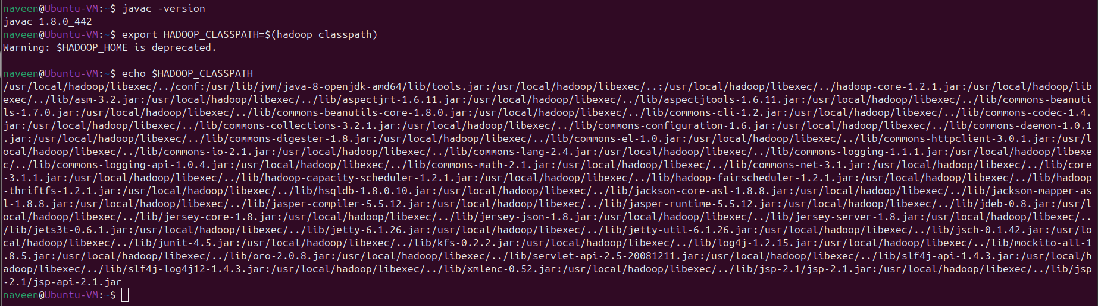

1. Create directory reducesidejoin/Input to store input text files in Hadoop.

1. Place the input text files in the created directory.

1. Check the files by going to HDFS NameNode Web UI using the port 50070.

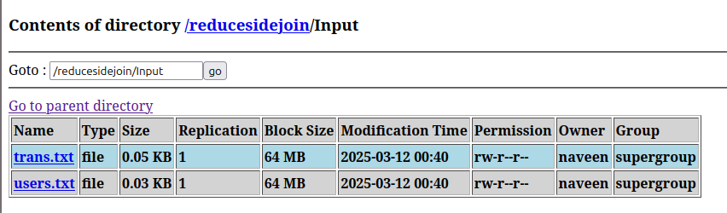

1. Compile the ReduceSideJoin.java and store it in the classfile and create reducejoin.jar

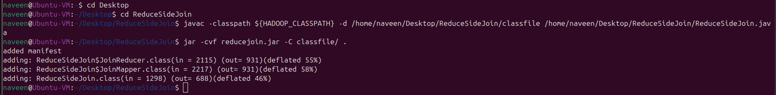

1. Run the Hadoop job and store the output

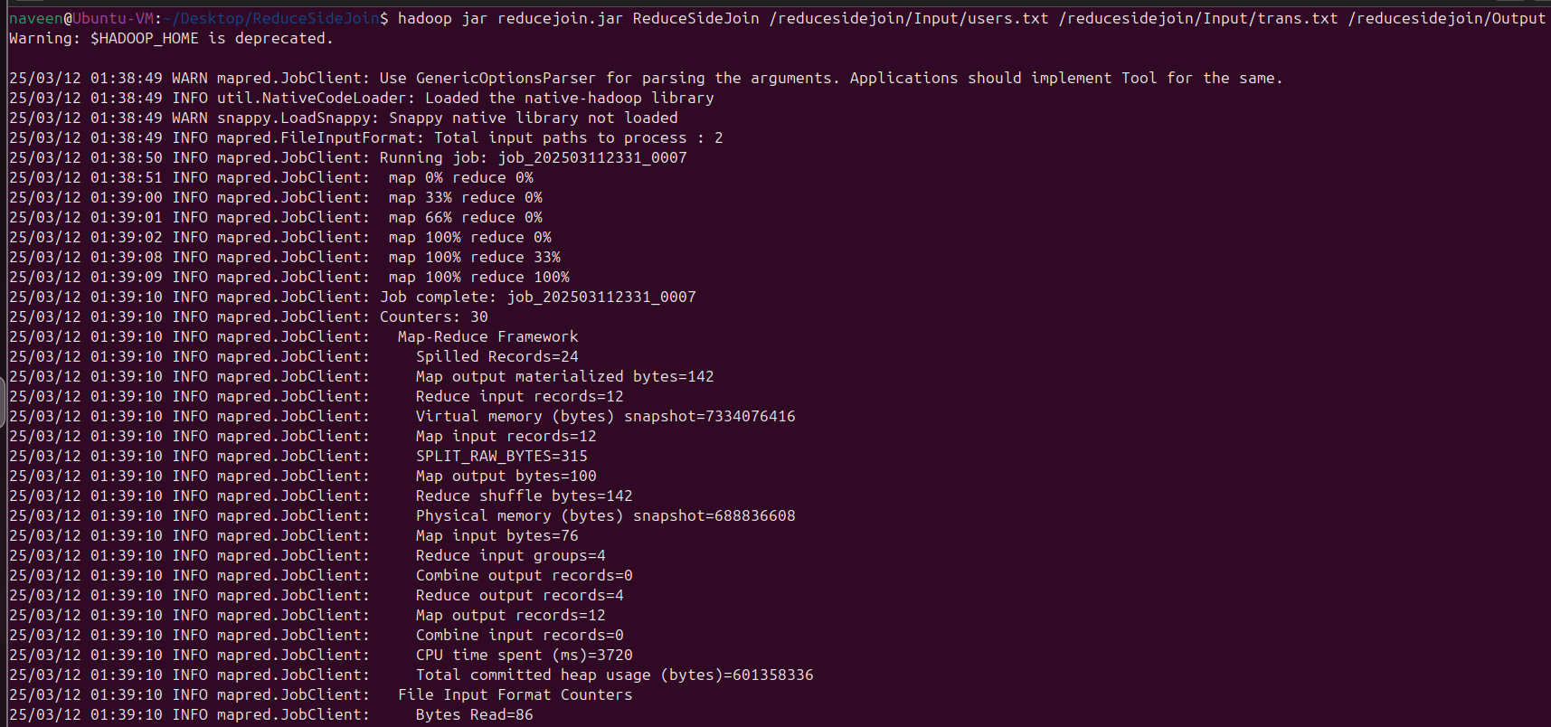

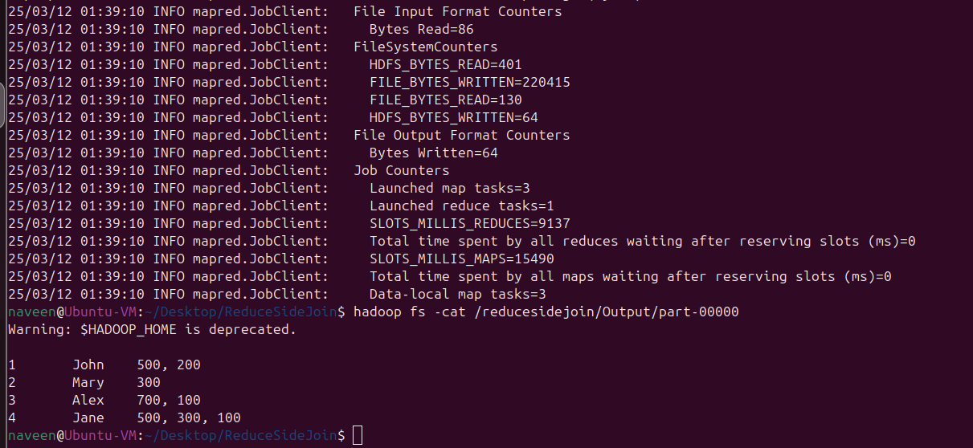

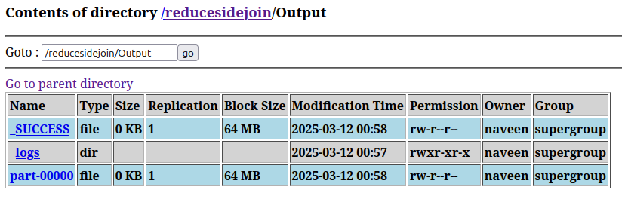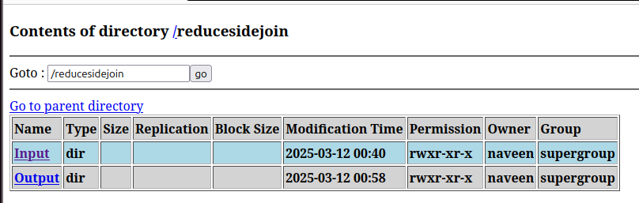

**Output:**

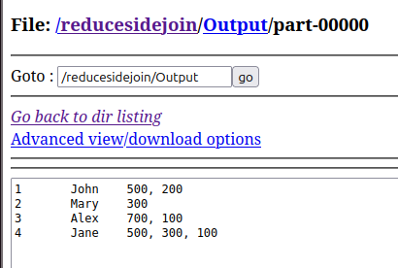

**Result:** Successfully performed a reduce side join operation using MapReduce, merging user details with their transactions based on ID.